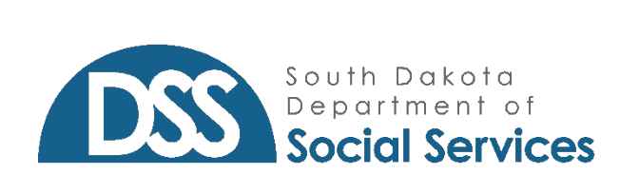
x

FOR IMMEDIATE RELEASE
MEDIA CONTACT: Emily.richardt@state.sd.us or 605.773.3165

A Time for Support and Sympathy: International Survivors of Suicide Loss Day
PIERRE, SD – This year, International Survivors of Suicide Loss Day falls on November 18, 2023. It serves as an opportunity for the community to come together, acknowledge the challenges faced by survivors and reaffirm our commitment by offering support.
Suicide is a leading cause of death in South Dakota and leaves a lasting impact on the survivors left behind. In 2022 alone, we lost 192 South Dakotans to suicide. The holidays can be an especially difficult time for survivors of suicide loss, which is why Survivors of Suicide Loss Day takes place every year on the Saturday before Thanksgiving.
Grief caused from suicide is complex. It brings an intense range of emotions that may be unfamiliar and uncontrollable. It’s important to let others know they are not alone. Survivors of Suicide Loss Day exists to address the stigma surrounding suicide, offer support to those in need and raise awareness about suicide prevention and mental health.
Survivors of Suicide Loss Day also presents an opportunity to find strength within ourselves and along other suicide loss survivors. Designated programs, events and resources help survivors gain new understanding of suicide, mental health and grief. This day aims to share a message of home and healing to all affected by suicide and encourage everyone to check in on those around you.
For more information about Survivors of Suicide Loss Day events and resources in South Dakota, visit our website at SDBehavioralHealth.gov and SDSuicidePrevention.org.
-30-
